727721EUIT187
YUVAN SANKAR S
DAY 5
TASK 1:
package Day_05.Day5;

import org.openqa.selenium.By;
import org.openqa.selenium.WebDriver;
import org.openqa.selenium.WebElement;
import org.openqa.selenium.chrome.ChromeDriver;
import org.openqa.selenium.chrome.ChromeOptions;
import org.openqa.selenium.interactions.Actions;

import io.github.bonigarcia.wdm.WebDriverManager;

public class CE_01 {

public static void main(String[] args) {
// TODO Auto-generated method stub
ChromeOptions co=new ChromeOptions();
co.addArguments("--remote-allow-origins=*");
WebDriverManager.chromedriver().setup();
WebDriver driver=new ChromeDriver(co);
driver.get("https://demoqa.com/droppable/");
driver.manage().window().maximize();
WebElement drag=driver.findElement(By.id("draggable"));
WebElement drop=driver.findElement(By.id("droppable"));
Actions a=new Actions(driver);
a.dragAndDrop(drag,drop).build().perform();
}

}
TASK 2:
package Day_05.Day5;

import org.openqa.selenium.By;
import org.openqa.selenium.WebDriver;
import org.openqa.selenium.WebElement;
import org.openqa.selenium.chrome.ChromeDriver;
import org.openqa.selenium.chrome.ChromeOptions;
import org.openqa.selenium.interactions.Actions;
import io.github.bonigarcia.wdm.WebDriverManager;

public class CE_02 {

public static void main(String[] args) {
// TODO Auto-generated method stub
ChromeOptions co=new ChromeOptions();
co.addArguments("--remote-allow-origins=*");
WebDriverManager.chromedriver().setup();
WebDriver driver=new ChromeDriver(co);
driver.get("https://jqueryui.com/droppable/");
driver.manage().window().maximize();
driver.switchTo().frame(0);
WebElement drag=driver.findElement(By.id("draggable"));
WebElement drop=driver.findElement(By.id("droppable"));
Actions a=new Actions(driver);
a.dragAndDrop(drag,drop).build().perform();
}

}
TASK 3:
package Day_05.Day5;
import org.openqa.selenium.Alert;
import org.openqa.selenium.By;
import org.openqa.selenium.WebDriver;
import org.openqa.selenium.WebElement;
import org.openqa.selenium.chrome.ChromeDriver;
import org.openqa.selenium.chrome.ChromeOptions;
import io.github.bonigarcia.wdm.WebDriverManager;
public class CE_03 {
public static void main(String[] args) throws InterruptedException{
WebDriverManager.chromedriver().setup();
ChromeOptions co=new ChromeOptions();
co.addArguments("--remote-allow-origins=*");
WebDriver driver=new ChromeDriver(co);
driver.get("https://demo.guru99.com/test/delete_customer.php");
driver.manage().window().maximize();
WebElement txtBox1=driver.findElement(By.name("cusid"));
txtBox1.sendKeys("401");
WebElement submitBtn=driver.findElement(By.name("submit"));
submitBtn.click();
Alert alert1=driver.switchTo().alert();
Thread.sleep(3000);
alert1.dismiss();
txtBox1.sendKeys("402");
submitBtn.click();
Alert alert2=driver.switchTo().alert();
alert2.accept();
Alert alert3=driver.switchTo().alert();
String txt=alert3.getText();
alert3.accept();
System.out.println(txt);

}

}
OUTPUT:
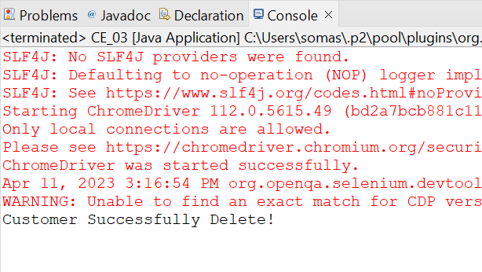
TASK 4:
package Day_05.Day5;

import org.openqa.selenium.By;
import org.openqa.selenium.WebDriver;
import org.openqa.selenium.WebElement;
import org.openqa.selenium.chrome.ChromeDriver;
import org.openqa.selenium.chrome.ChromeOptions;

import io.github.bonigarcia.wdm.WebDriverManager;

public class CE_04 {

public static void main(String[] args) {
// TODO Auto-generated method stub
ChromeOptions co=new ChromeOptions();
co.addArguments("--remote-allow-origins=*");
WebDriverManager.chromedriver().setup();
WebDriver driver=new ChromeDriver(co);
driver.get("https://www.abhibus.com/bus-ticket-booking");
driver.manage().window().maximize();
driver.navigate().to("https://www.abhibus.com/bus-ticket-booking");
WebElement date=driver.findElement(By.xpath("//*[@id=\"datepicker1\"]"));
date.click();

WebElement dat=driver.findElement(By.xpath("/html/body/div[1]/div[2]/table/tbody/tr[1]/td[3]/a"));
dat.click();

WebElement from=driver.findElement(By.xpath("/html/body/section[1]/div/div[2]/form/div/div/div[1]/div[1]/input[1]"));
from.sendKeys("Coimbatore Bypass");

WebElement to=driver.findElement(By.xpath("/html/body/section[1]/div/div[2]/form/div/div/div[1]/div[2]/input[1]"));
to.sendKeys("Vellore Bypass");
}

}

TASK 5:
package Day_05.Day5;
import org.openqa.selenium.By;
import org.openqa.selenium.Keys;
import org.openqa.selenium.WebDriver;
import org.openqa.selenium.chrome.ChromeDriver;
import org.openqa.selenium.chrome.ChromeOptions;
import io.github.bonigarcia.wdm.WebDriverManager;
public class CE_05 {
public static void main(String[] args) {
// TODO Auto-generated method stub
ChromeOptions co=new ChromeOptions();
co.addArguments("--remote-allow-origins=*");
WebDriverManager.chromedriver().setup();
WebDriver driver=new ChromeDriver(co);
driver.get("https://www.google.com/");
driver.manage().window().maximize();
driver.findElement(By.name("q")).sendKeys("Apple");
driver.findElement(By.name("q")).sendKeys(Keys.ENTER);

System.out.println(driver.getWindowHandle());
System.out.println(driver.getTitle());

driver.get("https://www.google.com/");
driver.manage().window().maximize();
driver.findElement(By.name("q")).sendKeys("Selenium");
driver.findElement(By.name("q")).sendKeys(Keys.ENTER);

System.out.println(driver.getWindowHandle());
System.out.println(driver.getTitle());

driver.get("https://www.google.com/");
driver.manage().window().maximize();
driver.findElement(By.name("q")).sendKeys("Cucumber");
driver.findElement(By.name("q")).sendKeys(Keys.ENTER);

System.out.println(driver.getWindowHandle());
System.out.println(driver.getTitle());

}

}
OUTPUT:
